BLOCK WISE INFORMATION OF DISTRICT SHAHDOL

S.No. | Block | Particular
1 | Name of the block | Sohagpur
2 | Name of the district | Shahdol
3 | Total geographical area,(ha) | 81160
4 | Number of villages | 188
5 | Net cropped area(ha) | 57850
6 | Gross cropped area(ha) | 57850
7 | Major soil type | 70 % Medium black soil and 30% mix red and black
8 | Topography | 70 % plain and 30% undulated
9 | Soil depth | More than 100 cm
10 | Soil texture | Clay, clay loam, sandy clay loam
11 | Normal annual rainfall, mm (month wise)
  Jan | Feb | Mar | Apr | May | Jun | Jul | Aug | Sep | Oct | Nov | Dec
  27.4 | 29.5 | 20.5 | 2.3 | 1.0 | 143.5 | 388.4 | 384.1 | 218.4 | 51.6 | 15.7 | 27.4
12 | Minimum & maximum temperature (month wise)
  Temp. | Jan | Feb | Mar | Apr | May | Jun | Jul | Aug | Sep | Oct | Nov | Dec
  Max | 27.4 | 33.4 | 38.8 | 43.5 | 44.9 | 42.0 | 34.8 | 33.4 | 32.0 | 33.7 | 31.5 | 27.1
  MIn | 4.3 | 5 | 12.7 | 19.3 | 22.4 | 23.9 | 22.3 | 23.2 | 17.3 | 13.0 | 9.4 | 3.1
13 | Fallow land (Kharif , Rabi separately) (ha) | Kharif = 0 , Rabi = 22410
14 | Permanent fallow land (ha) | 3900
15 | Cropping intensity (%) | 165
16 | Major field crops area & productivity
 | - Kharif
  Crop | Area(ha) | Productivity(kg/ha)
  Rice | 24500 | 4000
  Soybean | 17000 | 1800
  Pigeonpea | 3200 | 1250
 | - Rabi
  Crop | Area(ha) | Productivity(kg/ha)
  Wheat | 21000 | 2750
  Lentil | 2250 | 600
  Gram | 5470 | 1000
 | - Summer
  Crop | Area(ha) | Productivity(kg/ha)
  -
17 | Potential crop wise yield in the block based on FLD data
  Crop | Potential yield(kg/ha)
  Rice | 6000
  Soybean | 2800
  Pigeonpea | 2600
  Wheat | 4800
  Lentil | 1400
  Gram | 2200
18 | Crop wise are and productivity of horticulture crops
  Crop | Area(ha) | Productivity(kg/ha)
  Mango | 149 | 17920
  Citrus | 120 | 18420
  Guava | 124 | 19370
  Drumstick | 51.46 | 8460
  Tomato | 346 | 28780
  Garden pea | 184 | 11600
  Onion | 372 | 26880
  Cauliflower | 205 | 25680
19 | Area under forest (ha) | 19410
20 | NPK consumption (Kg/ha) | 28.6
21 | Source wise irrigated area(ha)
  Source | Area(ha)
  Ponds | 516
  Open wells | 1200
  Tube well | 2460
  Canals | 2300
  Other | 1500
  Total | 7876
22 | Irrigation (%) | 17.2
23 | Major live stocks & population
  Livestock | Population(No.)
  Cattle | 16106
  Buffalo | 3282
  Sheep, Goat | 4900
  Poultry | 400000
24 | Major problems of the block | Lack of Irrigation, Free grazing, low organic matter in soil, termite problem, damage caused by forest animals, imbalanced use of fertilizers
25 | Map of the block with soil type | Mentioned in Fig. 1
26 | Opportunities in the block | Soil management, Hi-tech vegetable cultivation, Soil test based nutrient management, recycling of organic manuring , Tubercrops, plantation crops, milk production
27 | Source of information | JDA / DDA / SADO Office, Shahdol

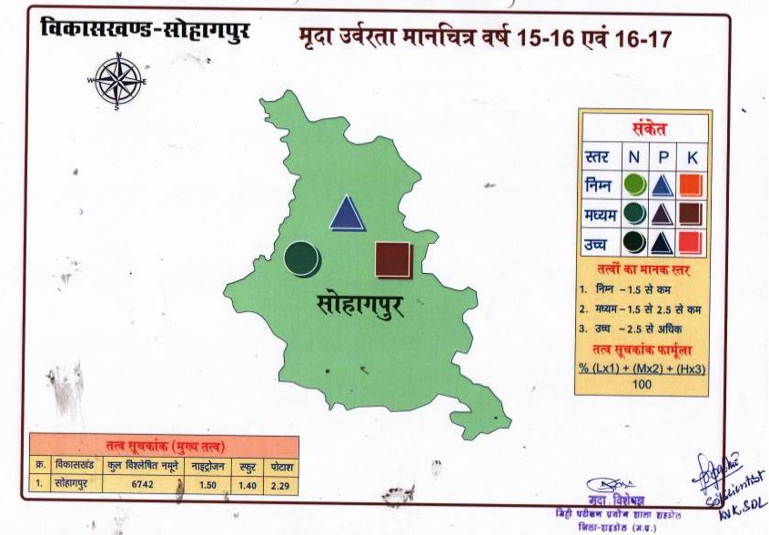
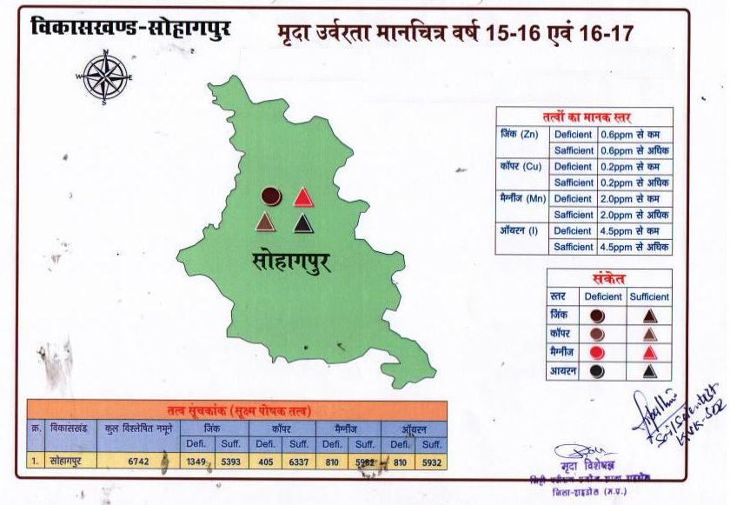
Fig. 1

Block wise information

S.No. | Block | Particular
1 | Name of the block | Gohaparu
2 | Name of the district | Shahdol
3 | Total geographical area,(ha) | 91143
4 | Number of villages | 129
5 | Net cropped area(ha) | 30629
6 | Gross cropped area(ha) | 35807
7 | Major soil type | Light soil
8 | Topography | 30 % undulated and rest plain
9 | Soil depth | Shallow
10 | Soil texture | Sandy-loam
11 | Normal annual rainfall, mm (month wise)
  Jan | Feb | Mar | Apr | May | Jun | Jul | Aug | Sep | Oct | Nov | Dec
  27.4 | 29.5 | 20.5 | 2.3 | 1.0 | 143.5 | 388.4 | 384.1 | 218.4 | 51.6 | 15.7 | 27.4
12 | Minimum & maximum temperature (month wise)
  Temp. | Jan | Feb | Mar | Apr | May | Jun | Jul | Aug | Sep | Oct | Nov | Dec
  Max | 27.1 | 33.1 | 38.4 | 43.1 | 44.5 | 41.6 | 34.5 | 33.1 | 31.7 | 33.4 | 31.2 | 26.8
  MIn | 4.3 | 5 | 12.6 | 19.1 | 22.2 | 23.7 | 22.1 | 23 | 17.1 | 12.9 | 9.3 | 3.1
13 | Fallow land (Kharif , Rabi separately) (ha) | Kharif = 0 , Rabi = 24661
14 | Permanent fallow land (ha) | 4007
15 | Cropping intensity (%) | 99.8
16 | Major field crops area & productivity
 | - Kharif
  Crop | Area(ha) | Productivity(kg/ha)
  Rice | 17779 | 3510
  Blackgram | 4232 | 800
  Sesame | 2119 | 580
 | - Rabi
  Crop | Area(ha) | Productivity(kg/ha)
  Wheat | 4571 | 1650
  Gram | 1312 | 1150
  Mustard | 2061 | 930
 | - Summer
  Crop | Area(ha) | Productivity(kg/ha)
  -
17 | Potential crop wise yield in the block based on FLD data
  Crop | Potential yield(kg/ha)
  Rice | 5000
  Blackgram | 1200
  Sesame | 1000
  Wheat | 4500
  Gram | 1800
  Mustard | 1500
18 | Crop wise are and productivity of horticulture crops
  Crop | Area(ha) | Productivity(kg/ha)
  Mango | 139 | 17920
  Lemon | 103 | 18130
  Guava | 109 | 19360
  Munga | 26 | 8410
  Tomato | 181 | 27720
  Garden pea | 162 | 11250
  Onion | 129 | 26460
19 | Area under forest (ha) | 51755
20 | NPK consumption (Kg/ha) | 12.5
21 | Source wise irrigated area(ha)
  Source | Area(ha)
  Ponds | 780
  Open wells | 1710
  Tube well | 1554
  Canal | 1690
  Total | 5734
22 | Irrigation (%) | 20.05
23 | Major live stocks & population
  Livestock | Population(No.)
  Cattle | 81399
  Buffalo | 31297
  Sheep | 3030
  Goatry | 24546
  Poultry | 100000
24 | Major problems of the block | Lack of irrigation, Damage caused by forest animals, Undulated topography, after some time borewells do not function properly, low organic matter in soil, very poor inherant capacity of soil, termite problem, free grazing
25 | Map of the block with soil type | Mentioned in Fig. 2
26 | Opportunities in the block | Promotion scope for vermicompost and nutrient management, organic farming, horticulture crops specially plantation crops , milk production, Tuber crops, Plantation crops, custard apple, drumstick, karonda, bamboo cultivation
27 | Source of information | JDA / DDA / SADO Office, Shahdol

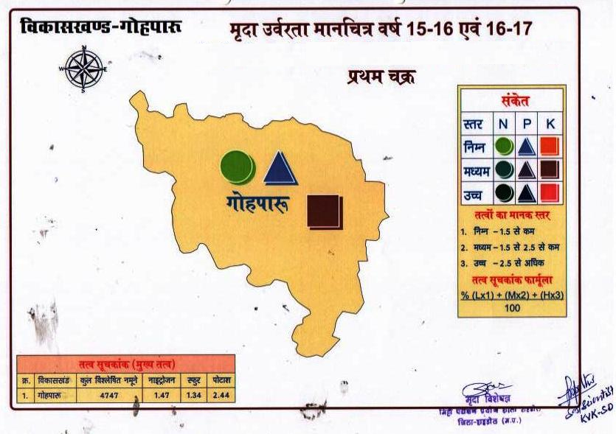

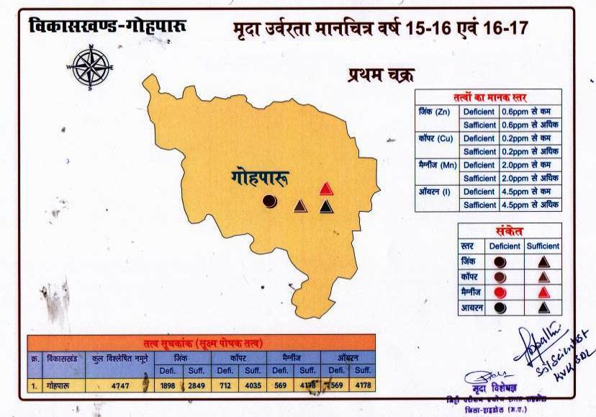

Fig. 2

Block wise information

S.No. | Block | Particular
1 | Name of the block | Jaisinghnagar
2 | Name of the district | Shahdol
3 | Total geographical area,(ha) | 153243
4 | Number of villages | 197
5 | Net cropped area(ha) | 50914
6 | Gross cropped area(ha) | 50914
7 | Major soil type | Light soil
8 | Topography | Undulated hilly
9 | Soil depth | Shallow
10 | Soil texture | Sandy to sandy loam
11 | Normal annual rainfall, mm (month wise)
  Jan | Feb | Mar | Apr | May | Jun | Jul | Aug | Sep | Oct | Nov | Dec
  30.2 | 23.4 | 15.0 | 1.5 | 0.6 | 128.2 | 349.5 | 326.1 | 159.8 | 36.8 | 12.2 | 30.2
12 | Minimum & maximum temperature (month wise)
  Temp. | Jan | Feb | Mar | Apr | May | Jun | Jul | Aug | Sep | Oct | Nov | Dec
  Max | 25.9 | 31.7 | 36.7 | 41.2 | 42.6 | 39.8 | 32.9 | 31.7 | 30.3 | 32 | 29.8 | 25.6
  MIn | 4.1 | 4.8 | 12.1 | 18.2 | 21.2 | 22.7 | 21.1 | 22 | 16.4 | 12.4 | 8.9 | 2.9
13 | Fallow land (Kharif , Rabi separately) (ha) | Kharif = 4430, Rabi = 32430
14 | Permanent fallow land (ha) | 13894
15 | Cropping intensity (%) | 140
16 | Major field crops area & productivity
 | - Kharif
  Crop | Area(ha) | Productivity(kg/ha)
  Rice | 23150 | 2629
  Blackgram | 1752 | 396
  Sesame | 1823 | 299
  Kodo | 3285 | 466
 | - Rabi
  Crop | Area(ha) | Productivity(kg/ha)
  Wheat | 3412 | 1755
  Linseed | 697 | 544
  Gram | 595 | 886
  Mustard | 752 | 816
 | - Summer
  Crop | Area(ha) | Productivity(kg/ha)
  -
17 | Potential crop wise yield in the block based on FLD data
  Crop | Potential yield(kg/ha)
  Rice | 5000
  Blackgram | 1200
  Sesame | 1000
  Kodo | 1200
  Wheat | 4500
  Linseed | 1100
  Gram | 1800
  Mustard | 1500
18 | Crop wise are and productivity of horticulture crops
  Crop | Area(ha) | Productivity(kg/ha)
  Mango | 148 | 17840
  Citrus | 112 | 18160
  Guava | 118 | 19340
  Aonla | 173 | 17050
  Tomato | 187 | 27650
  Garden pea | 171 | 11350
  Onion | 141 | 26590
  Brinjal | 218 | 23740
  Potato | 171 | 25490
  Cabbage | 165 | 24960
19 | Area under forest (ha) | 75376
20 | NPK consumption (Kg/ha) | 17.62
21 | Source wise irrigated area(ha)
  Source | Area(ha)
  Ponds
  Open wells
  Tube well
  River/Canal
  Total | 6942
22 | Irrigation (%) | 20.2
23 | Major live stocks & population
  Livestock | Population(No.)
  Cattle | 64002
  Buffalo | 16993
  Sheep, Goat | 12396
  Poultry | 67691
24 | Major problems of the block | Crop damage caused by forest animals, low organic matter in soil, very poor inherant capacity of soil, termite problem , free grazing, undulated land
25 | Map of the block with soil type | Mentioned in Fig. 3
26 | Opportunities in the block | Horticulture crops, Hi Tech vegetable Cultivation, Summer cultivation, promotion of tuber crops, cucurbitaceous crops at river bank in summer
27 | Source of information | JDA / DDA / SADO Office, Shahdol

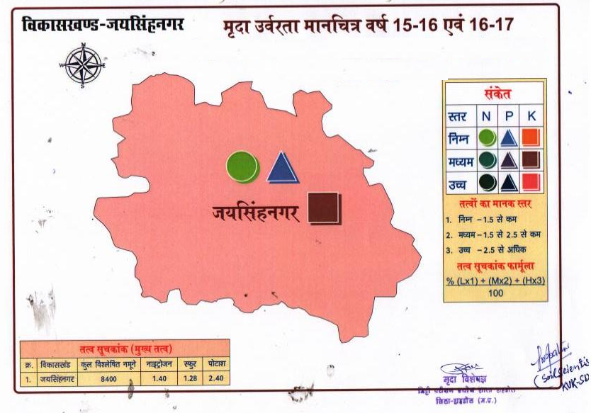
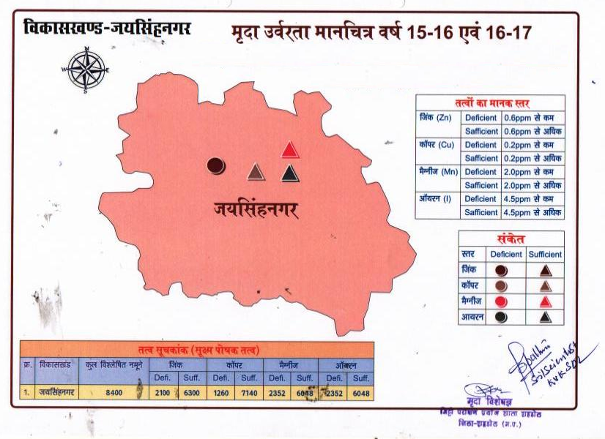
Fig. 3
Block wise information

S.No. | Block | Particular
1 | Name of the block | Beohari
2 | Name of the district | Shahdol
3 | Total geographical area,(ha) | 109503
4 | Number of villages | 137
5 | Net cropped area(ha) | 24210
6 | Gross cropped area(ha) | 35440
7 | Major soil type | Loamy
8 | Topography | 40% undulated and 60% plain
9 | Soil depth | More than 100 cm
10 | Soil texture | Sandy loam to clay loam
11 | Normal annual rainfall, mm (month wise)
  Jan | Feb | Mar | Apr | May | Jun | Jul | Aug | Sep | Oct | Nov | Dec
  30.2 | 23.4 | 15.0 | 1.5 | 0.6 | 128.2 | 349.5 | 326.1 | 159.8 | 36.8 | 12.2 | 30.2
12 | Minimum & maximum temperature (month wise)
  Temp. | Jan | Feb | Mar | Apr | May | Jun | Jul | Aug | Sep | Oct | Nov | Dec
  Max | 26.4 | 32.3 | 37.4 | 42 | 43.4 | 40.6 | 33.6 | 32.3 | 30.9 | 32.6 | 30.4 | 26.1
  MIn | 4.2 | 4.9 | 12.3 | 18.6 | 21.6 | 23.1 | 21.5 | 22.4 | 16.7 | 12.6 | 9.1 | 3
13 | Fallow land (Kharif , Rabi separately) (ha) | Kharif = 3100 , Rabi =4560
14 | Permanent fallow land (ha) | 6150
15 | Cropping intensity (%) | 161
16 | Major field crops area & productivity
 | - Kharif
  Crop | Area(ha) | Productivity(kg/ha)
  Rice | 15797 | 3400
  Maize | 1400 | 500
  Pigeonpea | 1655 | 600
 | - Rabi
  Crop | Area(ha) | Productivity(kg/ha)
  Wheat | 12150 | 2450
  Mustard | 1540 | 700
  Gram | 1858 | 1150
 | - Summer
  Crop | Area(ha) | Productivity(kg/ha)
  -
17 | Potential crop wise yield in the block based on FLD data
  Crop | Potential yield(kg/ha)
  Rice | 6000
  Maize | 1800
  Pigeonpea | 2600
  Wheat | 4800
  Mustard | 1700
  Gram | 2200
18 | Crop wise are and productivity of horticulture crops
  Crop | Area(ha) | Productivity(kg/ha)
  Mango | 138 | 17890
  Aonla | 179 | 17200
  Drumstick | 28 | 8390
  Brinjal | 318 | 23710
  Potato | 271 | 25490
  Tomato | 178 | 27780
  Garden pea | 158 | 11320
  Onion | 128 | 26680
19 | Area under forest (ha) | 43689
20 | NPK consumption (Kg/ha) | 23.5
21 | Source wise irrigated area(ha)
  Source | Area(ha)
  Ponds | 600
  Tube well | 1500
  Canal | 6400
  Total | 7900
22 | Irrigation (%) | 34
23 | Major live stocks & population
  Livestock | Population(No.)
  Cattle | 55078
  Buffalo | 13423
  Sheep | 3811
  Goatry | 11428
  Poultry | 110000
24 | Major problems of the block | Crop damage caused by forest animals, low organic matter in soil, imbalanced nutrient management, termite problem, open grazing
25 | Map of the block with soil type | Mentioned in Fig. 4
26 | Opportunities in the block | Horticulture crops, Hi Tech vegetable Cultivation, Summer cultivation, promotion of tuber crops, cucurbitaceous crops at river bank, milk production, bee keeping
27 | Source of information | JDA / DDA / SADO Office, Shahdol

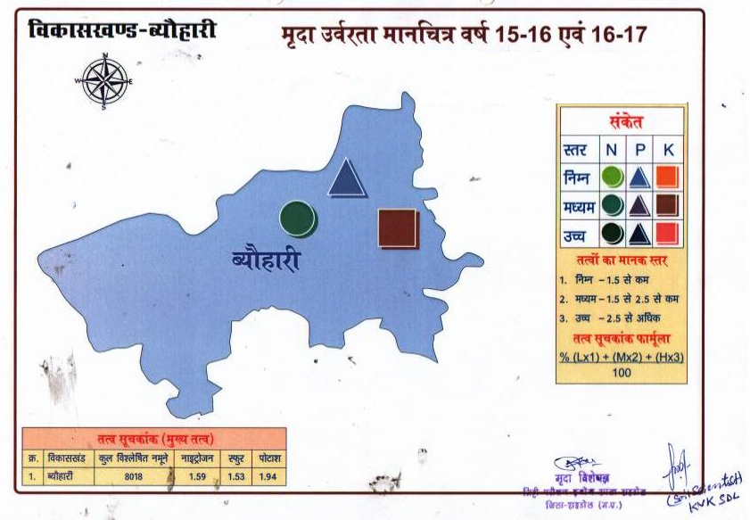
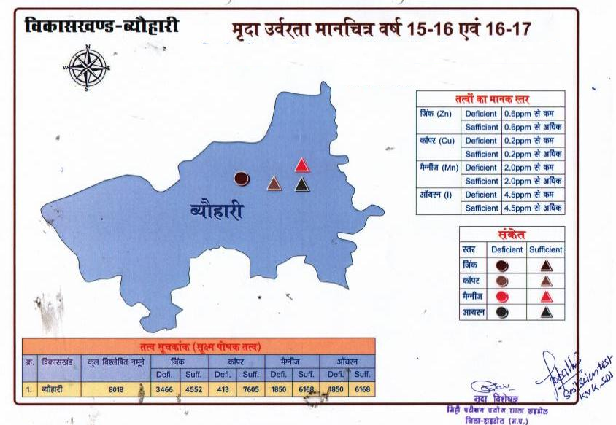
Fig 4

Block wise information
S.No. | Block | Particular
1 | Name of the block | Burhar
2 | Name of the district | Shahdol
3 | Total geographical area,(ha) | 125951
4 | Number of villages | 196
5 | Net cropped area(ha) | 59120
6 | Gross cropped area(ha) | 60210
7 | Major soil type | Light soil
8 | Topography | Undulated
9 | Soil depth | Shallow
10 | Soil texture | Sandy to sandy loam
11 | Normal annual rainfall, mm (month wise)
  Jan | Feb | Mar | Apr | May | Jun | Jul | Aug | Sep | Oct | Nov | Dec
  27.4 | 29.5 | 20.5 | 2.3 | 1.0 | 143.5 | 388.4 | 384.1 | 218.4 | 51.6 | 15.7 | 27.4
12 | Minimum & maximum temperature (month wise)
  Temp. | Jan | Feb | Mar | Apr | May | Jun | Jul | Aug | Sep | Oct | Nov | Dec
  Max | 26.9 | 32.7 | 38 | 42.7 | 44 | 41.2 | 34.1 | 32.7 | 31.4 | 33 | 30.9 | 26.6
  MIn | 4.2 | 4.9 | 12.5 | 18.9 | 22 | 23.4 | 21.9 | 22.8 | 17 | 12.8 | 9.2 | 3
13 | Fallow land (Kharif , Rabi separately) (ha) | Kharif = 690 , Rabi =48220
14 | Permanent fallow land (ha) | 18000
15 | Cropping intensity (%) | 125
16 | Major field crops area & productivity
 | - Kharif
  Crop | Area(ha) | Productivity(kg/ha)
  Rice | 42000 | 3800
  Maize | 2000 | 600
  Blackgram | 2100 | 460
 | - Rabi
  Crop | Area(ha) | Productivity(kg/ha)
  Wheat | 4500 | 2460
  Linseed | 850 | 400
  Gram | 7500 | 1238
 | - Summer
  Crop | Area(ha) | Productivity(kg/ha)
  -
17 | Potential crop wise yield in the block based on FLD data
  Crop | Potential yield(kg/ha)
  Rice | 5000
  Blackgram | 1200
  Maize | 1800
  Wheat | 4500
  Gram | 1800
  Linseed | 1100
18 | Crop wise are and productivity of horticulture crops
  Crop | Area(ha) | Productivity(kg/ha)
  Mango | 154 | 17650
  Citrus | 112 | 18150
  Guava | 122 | 19380
  Aonla | 172 | 19990
  Tomato | 197 | 27680
  Garden pea | 168 | 11630
  Cucumber | 228 | 15680
  Brinjal | 216 | 23570
  Potato | 183 | 25200
  Cabbage | 184 | 24530
  Onion | 136 | 26350
  Coriander | 125 | 650
19 | Area under forest (ha) | 38525
20 | NPK consumption (Kg/ha) | 12.2
21 | Source wise irrigated area(ha)
  Source | Area(ha)
  Ponds | 590
  Open wells | 1710
  Tube well | 1250
  Canal | 990
  Total | 4540
22 | Irrigation (%) | 7.54
23 | Major live stocks & population
  Livestock | Population(No.)
  Cattle | 65247
  Buffalo | 34692
  Goat | 15399
  Poultry | 200000
24 | Major problems of the block | Lack of irrigation, Damage caused by forest animals, Undulated topography, low organic matter in soil, very poor inherant capacity of soil, termite problem , open grazing
25 | Map of the block with soil type | Mentioned in Fig. 5
26 | Opportunities in the block | Promotion scope for vermicompost and nutrient management, organic farming, horticulture crops specially plantation crops , milk production, promotion of tuber crops, cucurbitaceous crops at river bank
27 | Source of information | JDA / DDA / SADO Office, Shahdol

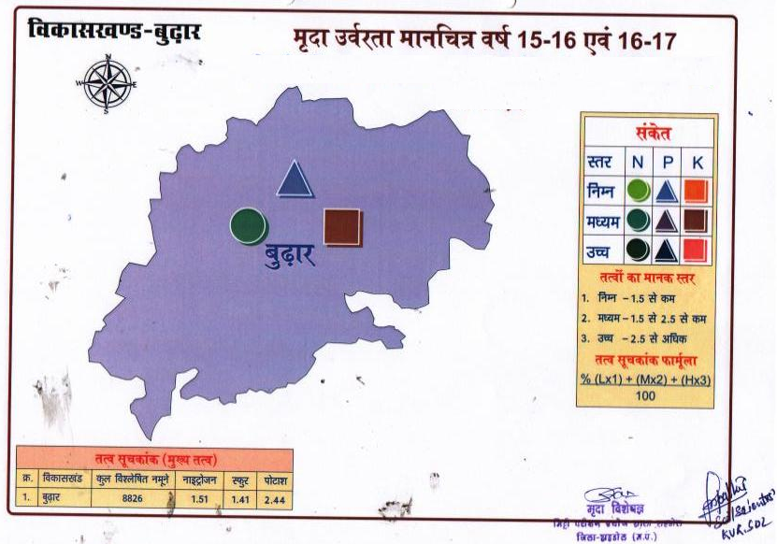
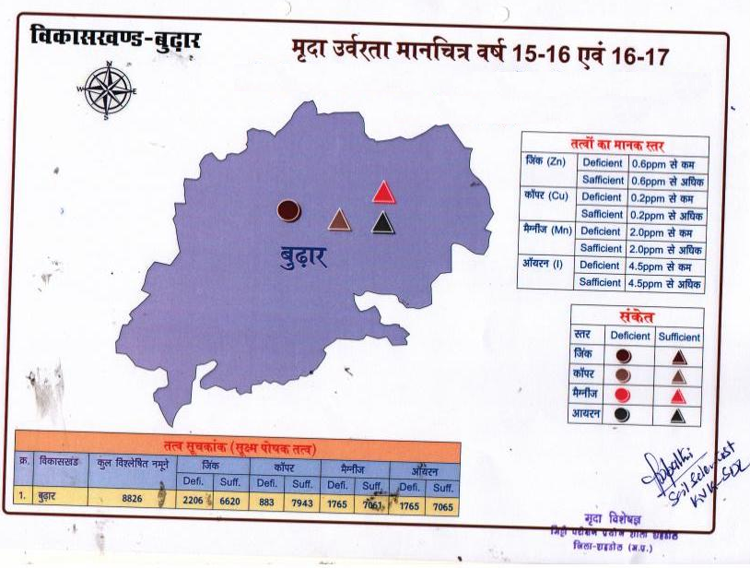
Fig. 5
- Name(s) of scientist collected the information : Sh. P.N.Tripathi, Scientist(Soil Science) & Sh. Deepak Chouhan, Scientist(Agril.Engr.), KVK Shahdol
- Name(s) of scientist compiled the information: Sh. P.N.Tripathi, Scientist(Soil Science), KVK Shahdol
- Dean / ADR / Station Incharge : Dr. Mriigendra Singh, Senior Scientist & Head, KVK Shahdol

